**Experiment-1.3**

**Aim of the Experiment :**

Image segmentation using Mean shift algorithm.

**Problem Description :**

**Mean Shift Segmentation:**

Mean shift segmentation is a computer vision technique used for image segmentation, which involves partitioning an image into multiple regions or segments based on the similarity of pixels. Unlike traditional segmentation methods such as thresholding or region growing, which require setting predefined parameters, mean shift segmentation is a data-driven approach that adaptively determines the segmentation boundaries based on the local density distribution of the image data.

Steps for Mean Shift Segmentation:

1. **Kernel Density Estimation:** Mean shift segmentation starts by representing the image as a collection of feature vectors, where each pixel in the image is described by its color or other relevant features. Then, a kernel density estimation is performed on these feature vectors. This essentially creates a density map where high-density regions represent areas with similar pixel characteristics.
2. **Mean Shift Iteration:** Mean shift is an iterative process where each pixel is shifted towards the mode (peak) of the density distribution within its local neighborhood. This shifting process is guided by a kernel function, typically a Gaussian kernel, which assigns weights to nearby pixels based on their similarity. Pixels are shifted in the direction of the weighted mean of the pixels within a certain radius, hence the name "mean shift". This process is repeated for each pixel until convergence.
3. **Segmentation:** After convergence, pixels that converge to the same mode are considered to belong to the same segment or region. Hence, segments are formed based on the convergence points in the feature space.
4. **Post-Processing:** Depending on the application and requirements, additional post-processing steps such as merging similar segments or refining boundaries may be applied to improve the segmentation results.

**Code :**

% Read an image from file

originalImage = imread('peppers.jpg');

% Display the original image

subplot(1,2,1)

imshow(originalImage);

title('Original Image');

% Convert the image to Lab color space

labImage = rgb2lab(originalImage);

% Reshape the image for mean shift

reshapedImage = reshape(labImage, [], 3);

% Perform mean shift clustering

[clusterIndices, ~] = meanShiftSegmentation(reshapedImage);

% Reshape the cluster indices to the original image size

segmentedImageMeanShift = reshape(clusterIndices, size(originalImage, 1), size(originalImage, 2));

% Display the segmented image using mean shift

subplot(1,2,2)

imshow(label2rgb(segmentedImageMeanShift));

title('Segmented Image (Mean Shift)');

sgtitle("Milan Sharma 23MAI10003")

% Implementation of the meanShiftSegmentation function

function [clusterIndices, clusterCenters] = meanShiftSegmentation(data, bandwidth)

if nargin < 2

bandwidth = 15; % Default bandwidth

end

[numPoints, ~] = size(data);

clusterIndices = zeros(numPoints, 1);

% Initialize cluster centers

clusterCenters = zeros(numPoints, size(data, 2));

% Iterate through each point

for i = 1:numPoints

x = data(i, :);

% Mean shift

while true

% Compute distances to all points

distances = sqrt(sum((repmat(x, numPoints, 1) - data).^2, 2));

% Find points within the bandwidth

withinBandwidth = distances < bandwidth;

nearbyPoints = data(withinBandwidth, :);

% Calculate mean shift vector

shift = mean(nearbyPoints, 1) - x;

% Update position

x = x + shift;

% Check for convergence

if norm(shift) < 1e-5

break;

end

end

% Assign cluster index

[~, clusterIndices(i)] = ismember(round(x), round(clusterCenters), 'rows');

% Update cluster center if new

if clusterIndices(i) == 0

clusterCenters(i, :) = x;

end

end

% Generate unique cluster indices

[~, ~, clusterIndices] = unique(clusterIndices);

end

**Output :**

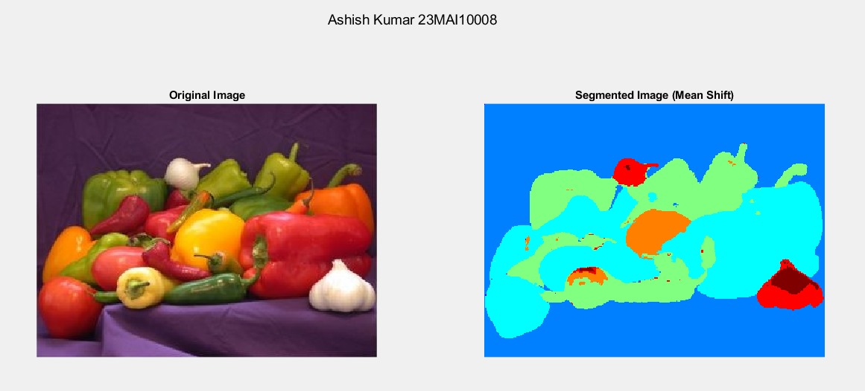

**Learning outcomes:**

1. Learnt about the concept of Image Segmentation.
2. Learnt about the Mean Shift Segmentation Technique.
3. Learnt about the Graph Cut Segmentation Technique.
4. Learnt about bandwidth and threshold for Mean Shift.
5. Learnt about use of Mask in Graph Cut Segmentation.